**COMPETENCY APPRAISAL MANUAL FOR EMPLOYEES FY2017 – FAQ**

**1/ Cannot login** [**https://renesas.ehr.com/**](https://renesas.ehr.com/)

* Login ID: company email address
* Password :

+ Employee who has been transferred to SingleDomain(＠renesas.com): Office365 password

+ Employee who has not been transferred to SingleDomain(＠renesas.com): DS password

(For initializing of DS password, please go to the link:http://rdp8a01.edc.renesas.com/xa00/password/pwdInit_renesas.jsp?language=en)

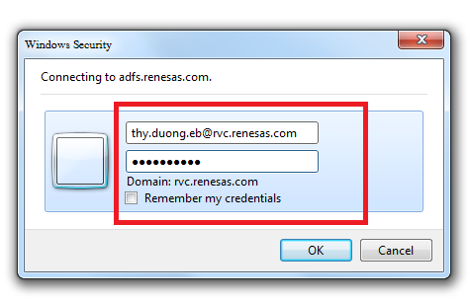

**2/ Cannot input your Comments at Current competency consists of seven core skill sets or load GHRIS page;**

If you can’t input your Comments at Current competency consists of seven core skill sets or load GHRIS page please check the version of your web browser.

If your version is older than ones listed below then please contact IT though helpdesk. We will support you to upgrade your browser.

*Microsoft Internet Explorer 9/10/11 (recommended)*

**3/ How to set Self-Assessments**

1. Key points on Self-Assessments: please read pages 9 of Competency Appraisal Manual for Employees:

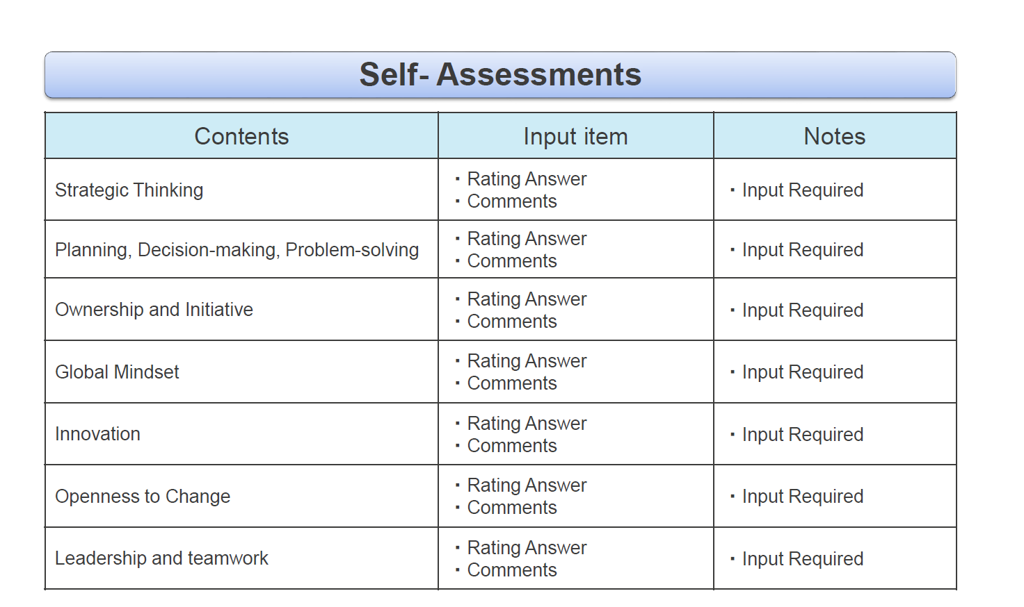

1. How to come “Self-Assessment”: please read pages 10 of Competency Appraisal Manual for Employees:

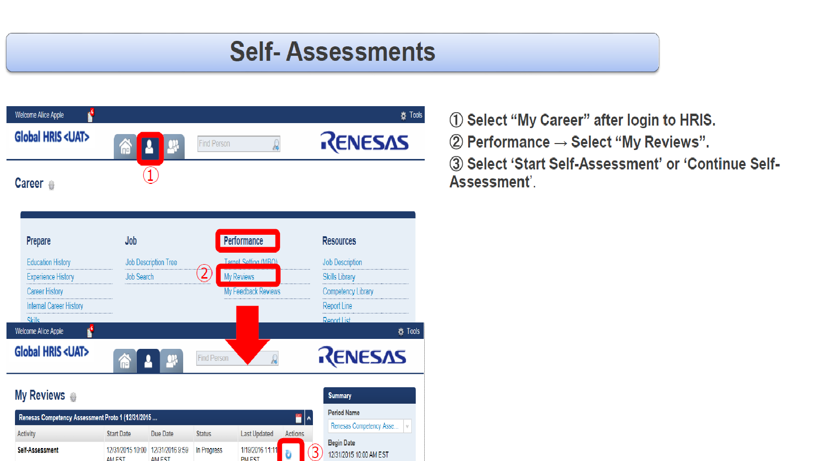

1. How to Input ‘Rating and Comments’: please read pages 11 of Competency Appraisal Manual for Employees:

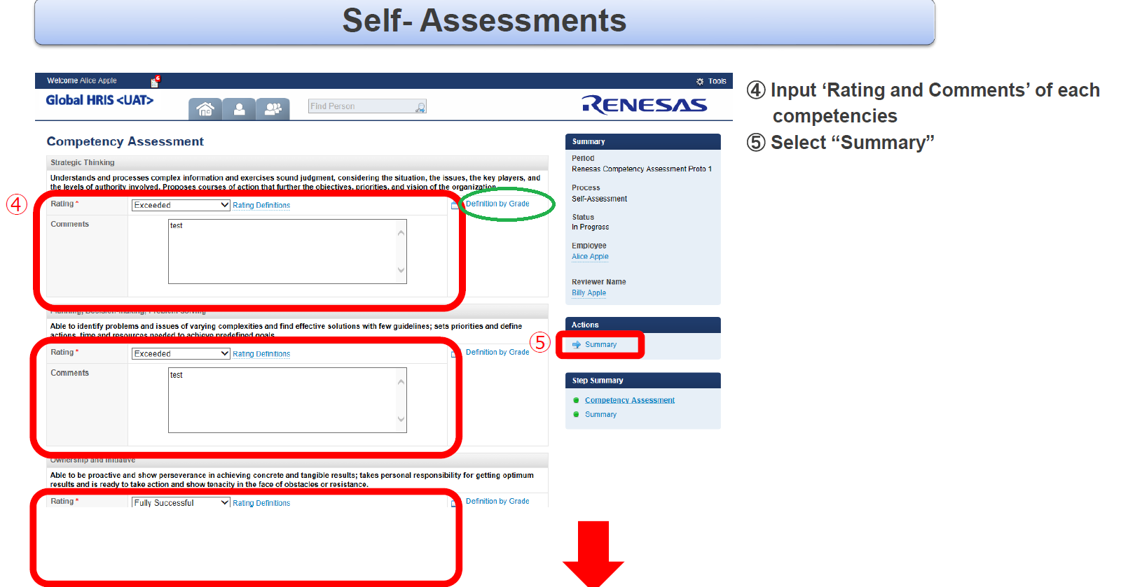

Note: In manual, at “Definition by Grade” that I marked green, in system, it is called “Expected Action by Grades”

1. How to submit: please read pages 12 of Competency Appraisal Manual for Employees:

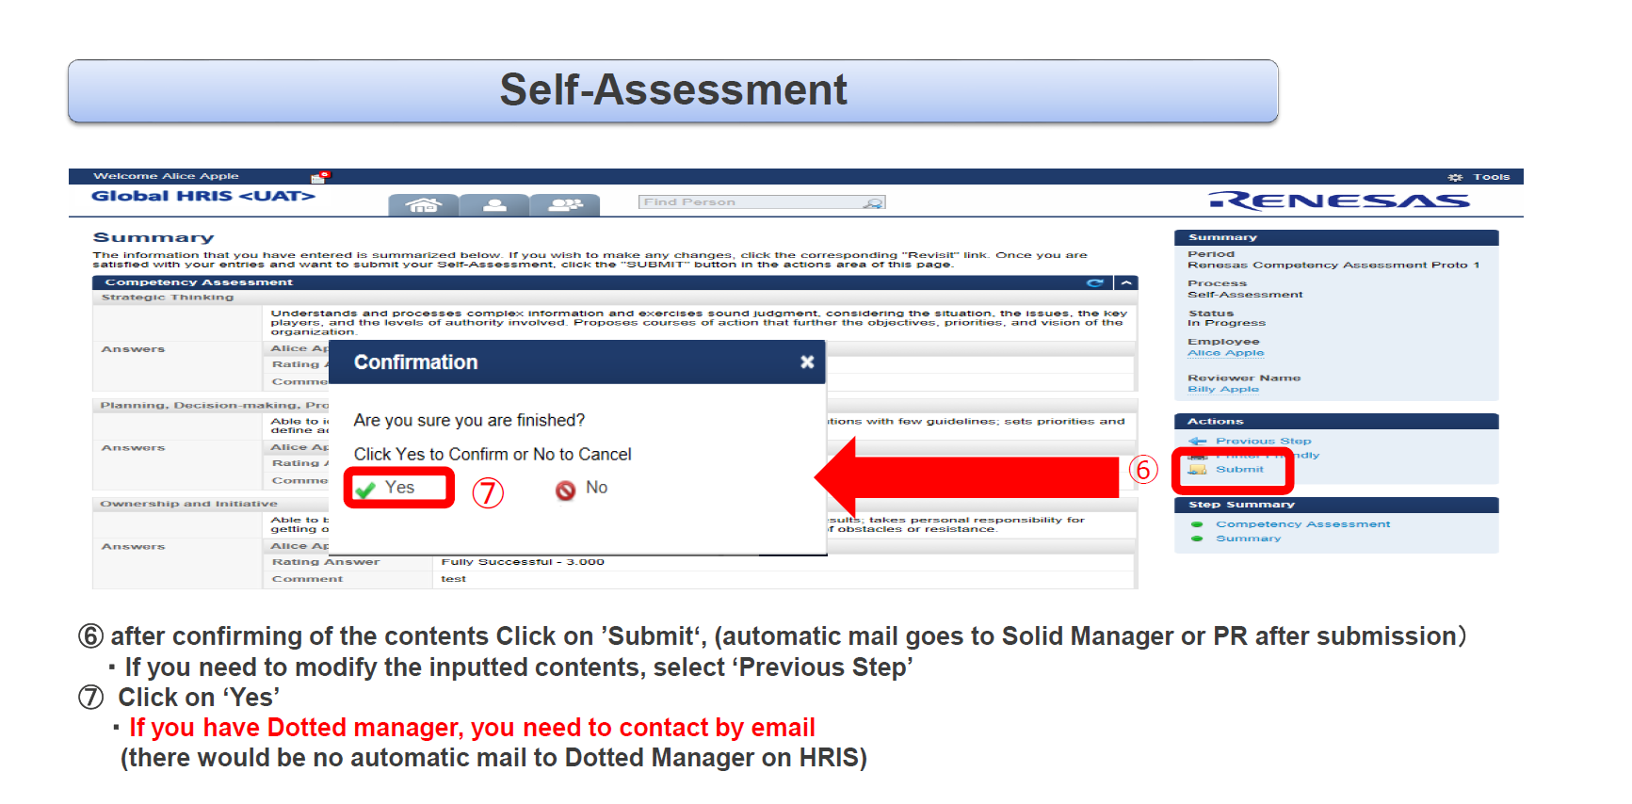

**4/ Feedback (e -signature):**

1. How to come Feedback (e -signature**)**: When it is ready, HR will inform to you. And please read pages 17 of Competency Appraisal Manual for Employees:

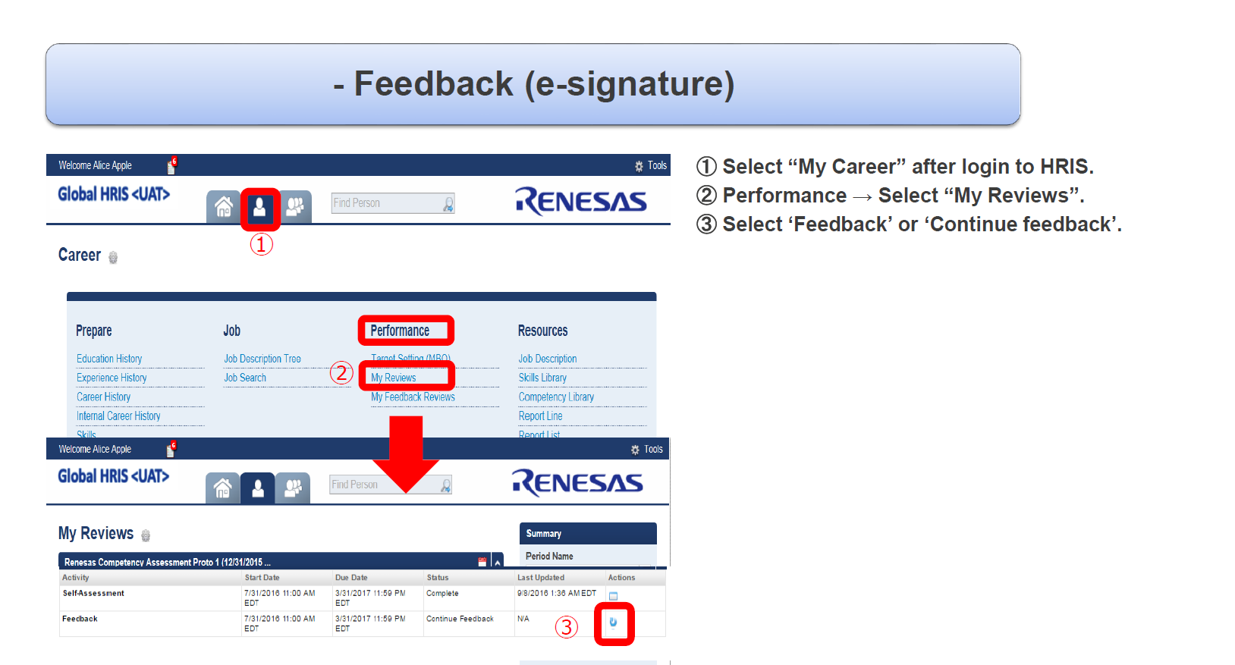

1. How to send your Comment and Signature: Please read 18 and 19 of Competency Appraisal Manual for Employees:

